**Course Project   
DeVry University  
College of Engineering and Information Sciences**

**Course Number: CEIS236**

* + **Crow’s Foot ERD**



* **Based on the ERD, a database that fulfills the operations described in this problem.**

**Screenshot of database created as:** finalproject_ceis236

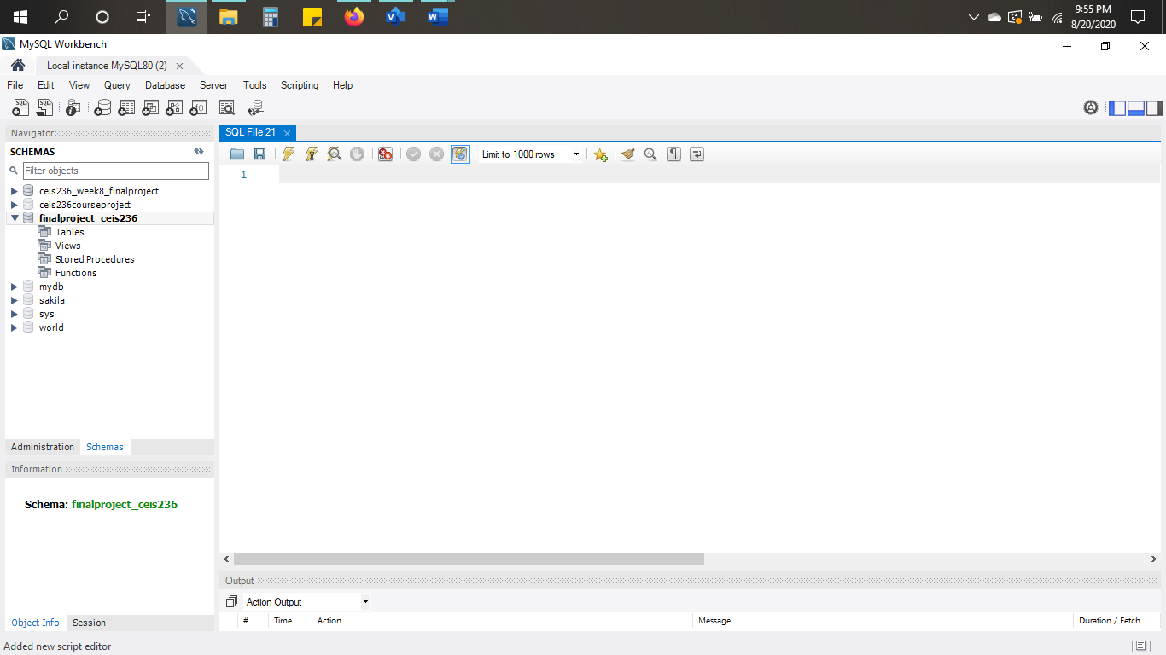

* **All of the required tables, keys, and required relationships.**

**Customer Table Creation Script / Screenshot in MySQL:**

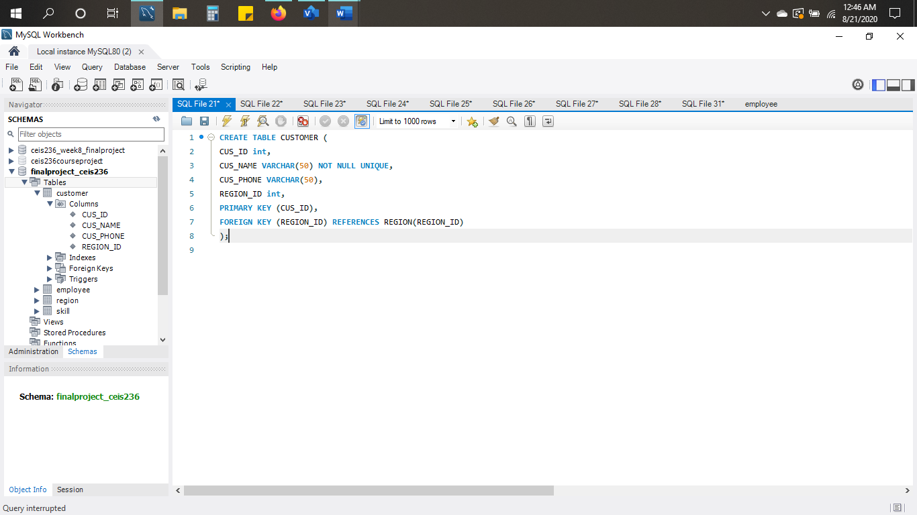CREATE TABLE CUSTOMER (

CUS_ID int,

CUS_NAME VARCHAR(50) NOT NULL UNIQUE,

CUS_PHONE VARCHAR(50),

REGION_ID int,

PRIMARY KEY (CUS_ID),

FOREIGN KEY (REGION_ID) REFERENCES REGION(REGION_ID)

);

**Employee Table Creation Script / Screenshot in MySQL:**

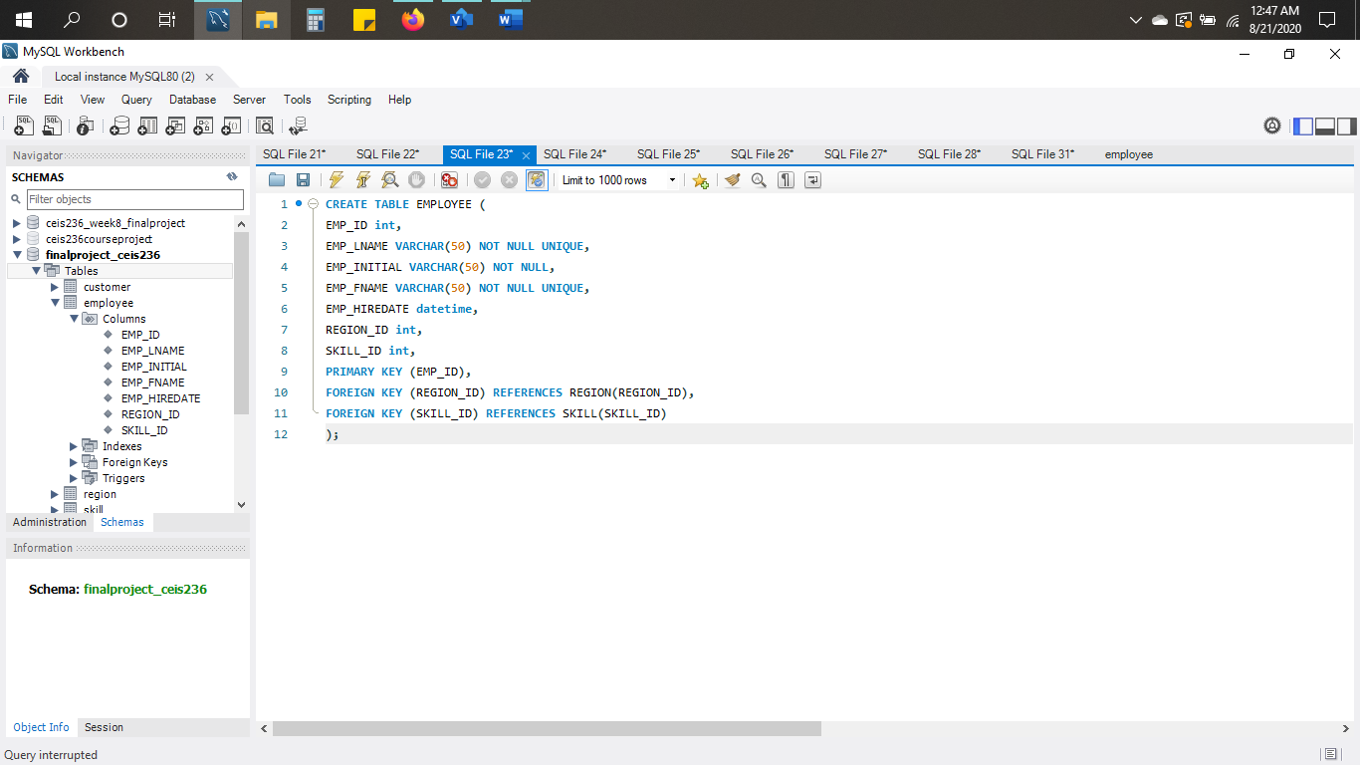

CREATE TABLE EMPLOYEE (

EMP_ID int,

EMP_LNAME VARCHAR(50) NOT NULL UNIQUE,

EMP_INITIAL VARCHAR(50) NOT NULL,

EMP_FNAME VARCHAR(50) NOT NULL UNIQUE,

EMP_HIREDATE datetime,

REGION_ID int,

SKILL_ID int,

PRIMARY KEY (EMP_ID),

FOREIGN KEY (REGION_ID) REFERENCES REGION(REGION_ID),

FOREIGN KEY (SKILL_ID) REFERENCES SKILL(SKILL_ID)

);

**Region Table Creation Script / Screenshot in MySQL:**

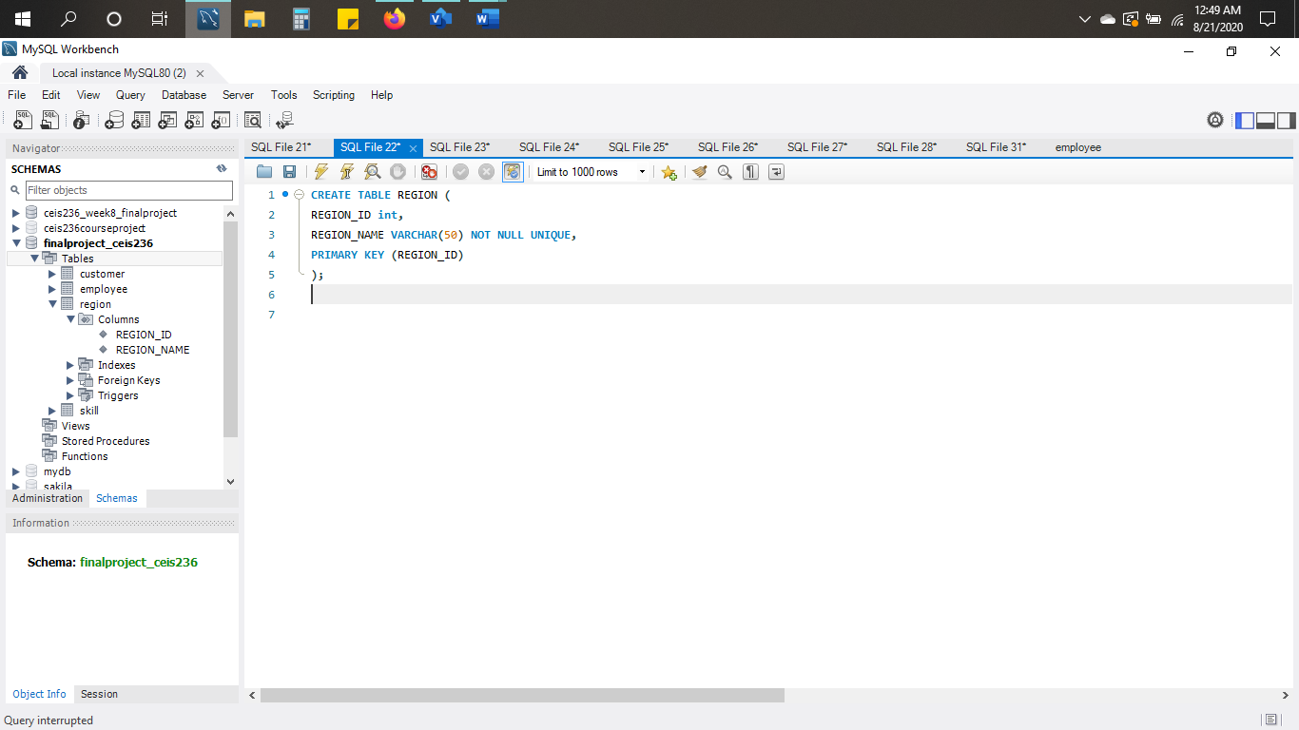

CREATE TABLE REGION (

REGION_ID int,

REGION_NAME VARCHAR(50) NOT NULL UNIQUE,

PRIMARY KEY (REGION_ID)

);

**Skill Table Creation Script / Screenshot in MySQL:**

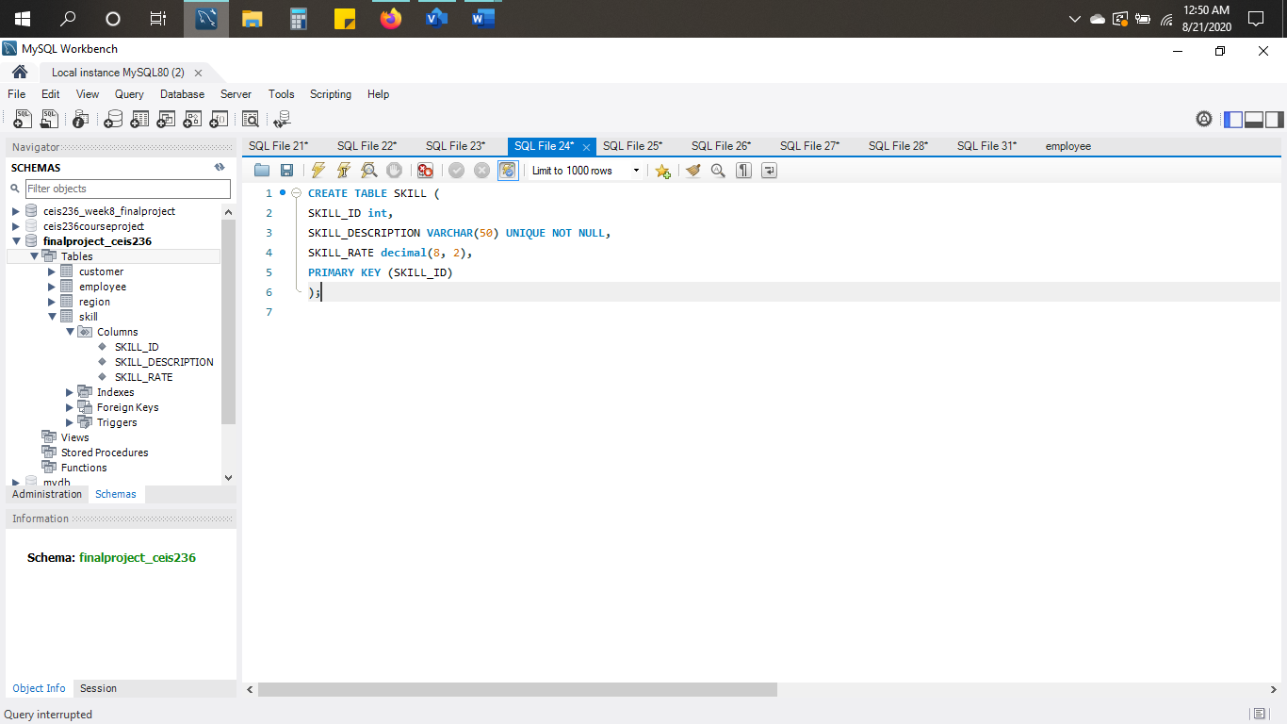

CREATE TABLE SKILL (

SKILL_ID int,

SKILL_DESCRIPTION VARCHAR(50) UNIQUE NOT NULL,

SKILL_RATE decimal(8, 2),

PRIMARY KEY (SKILL_ID)

);

* **Populated tables as indicated in the sample data and forms.**

**NOTE: You must be included as an employee in the database.**

**Customer Table (Populate table):**

INSERT INTO CUSTOMER VALUES ('1', 'See Rocks', '678-257-2857', '1');

INSERT INTO CUSTOMER VALUES ('2', 'Merk & Co', '695-444-2080', '2');

INSERT INTO CUSTOMER VALUES ('3', 'Hewlett Packard', '989-999-4747', '3');

INSERT INTO CUSTOMER VALUES ('4', 'General Electric', '855-954-8504', '4');

INSERT INTO CUSTOMER VALUES ('5', 'Bank of America', '832-432-1000', '5');

INSERT INTO CUSTOMER VALUES ('6', 'iHeartMedia', '210-822-2828', '6');

**Screenshot of insert values to Customer table:**

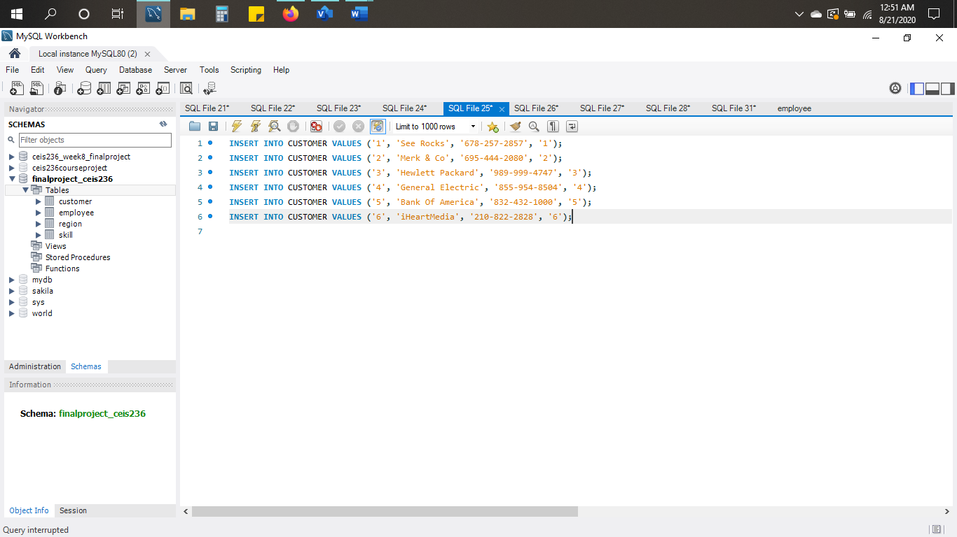

**Screenshot in MySQL of sample data in Customer table:**

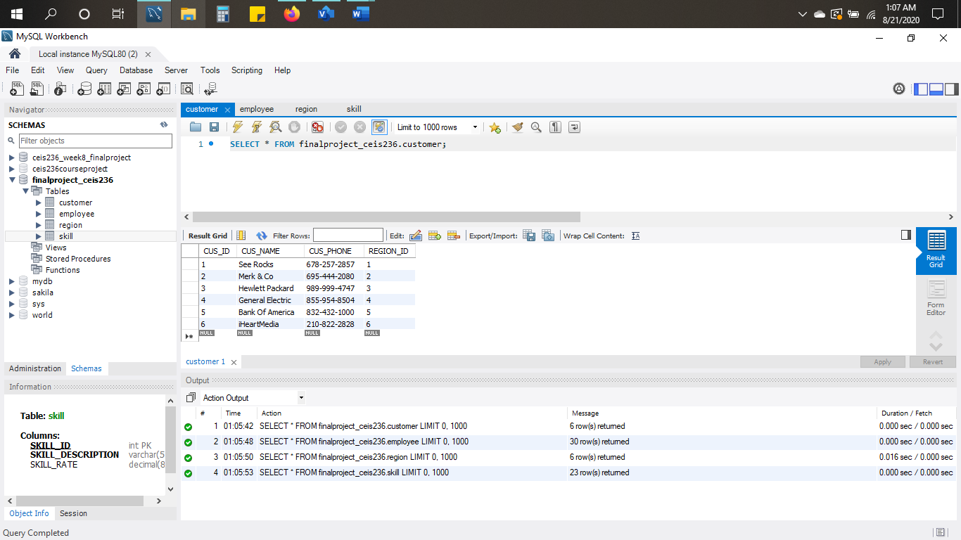

**Employee Table (Populate table): (Including my name on line 29 as directed from project instructions)**

INSERT INTO EMPLOYEE VALUES ('1', 'Seaton', 'M', 'Amy', '2002-2-7', '1', '19');

INSERT INTO EMPLOYEE VALUES ('2', 'Merlino', 'B', 'Nick', '2015-8-16', '3', '22');

INSERT INTO EMPLOYEE VALUES ('3', 'Cooper', 'D', 'Betty', '2000-9-15', '4', '3');

INSERT INTO EMPLOYEE VALUES ('4', 'Williams', 'R', 'Veronica', '2000-4-7', '2', '2');

INSERT INTO EMPLOYEE VALUES ('5', 'Amaya', 'A', 'Jerome', '2001-6-12', '5', '21');

INSERT INTO EMPLOYEE VALUES ('6', 'Hopkins', '', 'Molly', '2001-8-25', '6', '3');

INSERT INTO EMPLOYEE VALUES ('7', 'Kneller', 'Z', 'Eugene', '2014-11-26', '1', '4');

INSERT INTO EMPLOYEE VALUES ('8', 'Biafra', 'U', 'Mikal', '2001-1-9', '6', '5');

INSERT INTO EMPLOYEE VALUES ('9', 'Servold', 'F', 'Dakota', '2004-5-31', '2', '10');

INSERT INTO EMPLOYEE VALUES ('10', 'Patel', 'L', 'Mathew', '2001-7-14', '3', '17');

INSERT INTO EMPLOYEE VALUES ('11', 'Pilgram', 'I', 'Scott', '2010-9-16', '4', '1');

INSERT INTO EMPLOYEE VALUES ('12', 'Flowers', '', 'Ramona', '2016-10-31', '5', '1');

INSERT INTO EMPLOYEE VALUES ('13', 'Bishop', 'M', 'Henry', '2006-6-8', '2', '21');

INSERT INTO EMPLOYEE VALUES ('14', 'Glick', 'S', 'Corey', '1999-5-9', '6', '6');

INSERT INTO EMPLOYEE VALUES ('15', 'Campbell', 'S', 'Aidan', '2001-2-28', '3','13');

INSERT INTO EMPLOYEE VALUES ('16', 'Torres', 'M', 'Vanessa', '2012-3-8', '1', '7');

INSERT INTO EMPLOYEE VALUES ('17', 'Draper', 'D', 'Don', '1998-10-21', '4', '8');

INSERT INTO EMPLOYEE VALUES ('18', 'Taylor', 'A', 'Grant', '2000-8-9', '6', '9');

INSERT INTO EMPLOYEE VALUES ('19', 'Sterling', 'T', 'Roger', '2010-12-1', '5', '10');

INSERT INTO EMPLOYEE VALUES ('20', 'Gerwer', 'D', 'Frank', '2001-4-28', '2', '18');

INSERT INTO EMPLOYEE VALUES ('21', 'Dressen', '', 'Eric', '2000-3-2', '1', '11');

INSERT INTO EMPLOYEE VALUES ('22', 'Summers', '', 'Anna', '1999-1-1', '1', '12');

INSERT INTO EMPLOYEE VALUES ('23', 'England', 'V', 'Anthnoy', '1998-2-6', '1', '13');

INSERT INTO EMPLOYEE VALUES ('24', 'Demond', 'S', 'Beatrice', '2000-4-6', '1', '14');

INSERT INTO EMPLOYEE VALUES ('25', 'Yebra', '', 'Berenice', '2014-4-5', '1', '15');

INSERT INTO EMPLOYEE VALUES ('26', 'Caples', 'R', 'Curren', '2000-8-7', '1', '16');

INSERT INTO EMPLOYEE VALUES ('27', 'Leabres', '', 'Jeremy', '2000-12-3', '1', '20');

INSERT INTO EMPLOYEE VALUES ('28', 'Vosconcellos', '', 'Nora', '1999-6-5', '1', '23');

INSERT INTO EMPLOYEE VALUES ('29', 'Kimberly', 'G', 'Hernandez', '2015-1-5', '1', '10');

INSERT INTO EMPLOYEE VALUES ('30', 'Brevard', '', 'Samarria', '1998-4-15', '1', '17');

**Screenshot of insert values to Employee table:**

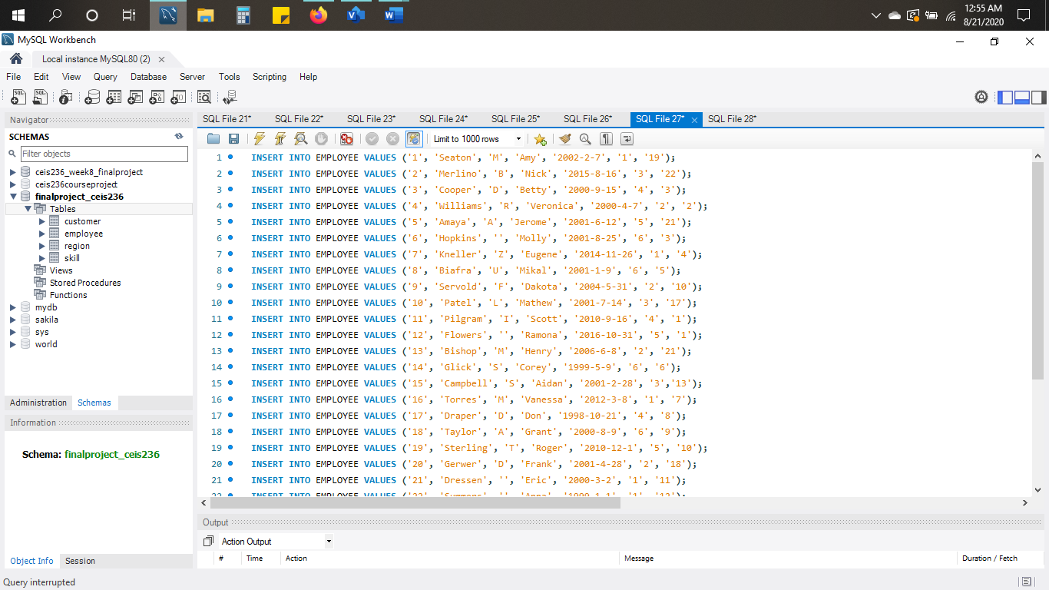

**Screenshot in MySQL of sample data in Employee table:**

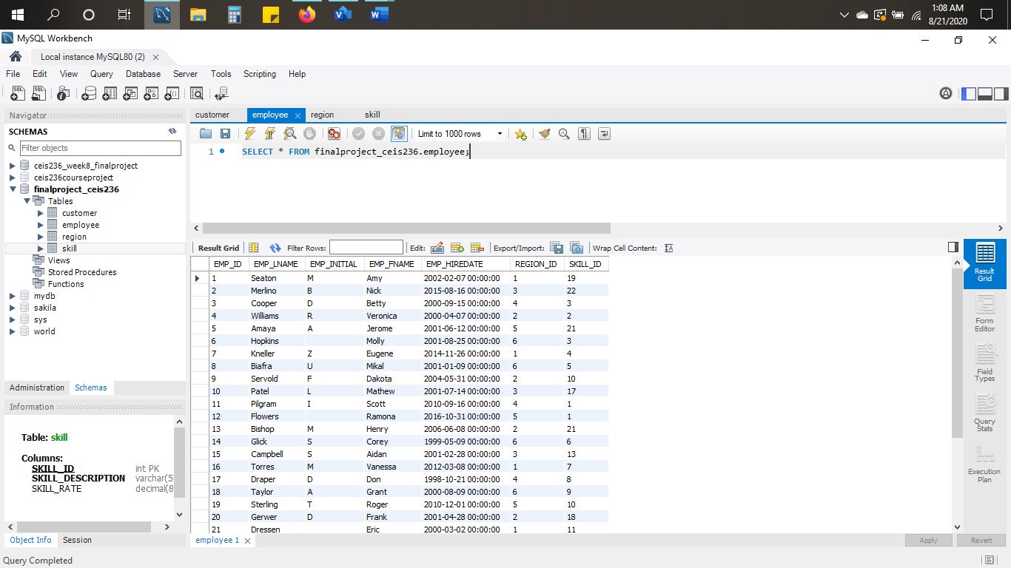

**Region Table (Populate table):**

INSERT INTO REGION VALUES ('1', 'NW');

INSERT INTO REGION VALUES ('2', 'SW' );

INSERT INTO REGION VALUES ('3', 'MN');

INSERT INTO REGION VALUES ('4', 'MS');

INSERT INTO REGION VALUES ('5', 'NE');

INSERT INTO REGION VALUES ('6', 'SE');

**Screenshot of insert values to Region table:**

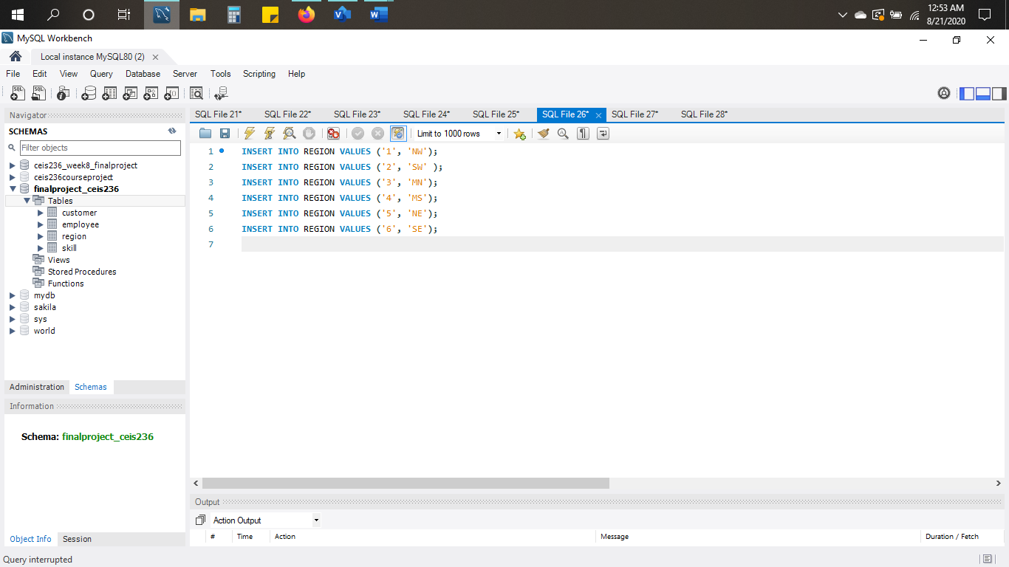

**Screenshot in MySQL of sample data in Region table:**

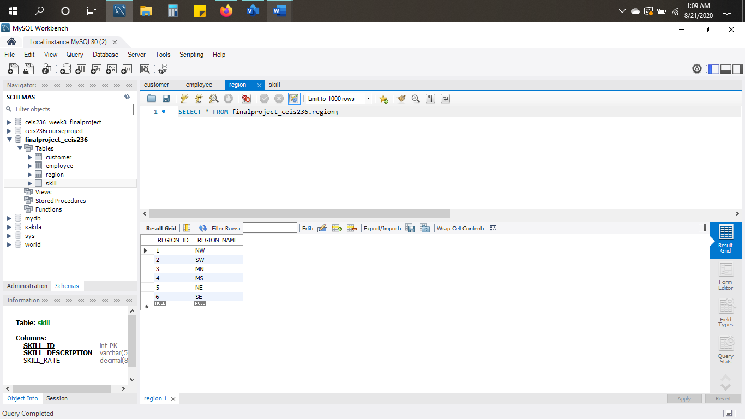

**Skill Table (Populate table):**

INSERT INTO SKILL VALUES ('1', 'Data Entry I', '12');

INSERT INTO SKILL VALUES ('2', 'Data Entry II', '15');

INSERT INTO SKILL VALUES ('3', 'System Analyst I', '18');

INSERT INTO SKILL VALUES ('4', 'System Analyst II', '21');

INSERT INTO SKILL VALUES ('5', 'Database Designer I', '50');

INSERT INTO SKILL VALUES ('6', 'Database Designer II', '75');

INSERT INTO SKILL VALUES ('7', 'Java I', '25');

INSERT INTO SKILL VALUES ('8', 'Java II', '30');

INSERT INTO SKILL VALUES ('9', 'C++ I', '35');

INSERT INTO SKILL VALUES ('10', 'C++ II', '45');

INSERT INTO SKILL VALUES ('11', 'Python I', '25');

INSERT INTO SKILL VALUES ('12', 'Python II', '35');

INSERT INTO SKILL VALUES ('13', 'Cold Fusion I', '60');

INSERT INTO SKILL VALUES ('14', 'Cold Fusion II', '75');

INSERT INTO SKILL VALUES ('15', 'ASP I', '60');

INSERT INTO SKILL VALUES ('16', 'ASP II', '70');

INSERT INTO SKILL VALUES ('17', 'Web Administrator', '50');

INSERT INTO SKILL VALUES ('18', 'Oracle DBA', '100');

INSERT INTO SKILL VALUES ('19', 'SQL Server DBA', '100');

INSERT INTO SKILL VALUES ('20', 'Network Eng I', '80');

INSERT INTO SKILL VALUES ('21', 'Network Eng II', '100');

INSERT INTO SKILL VALUES ('22', 'Technical Writer', '100');

INSERT INTO SKILL VALUES ('23', 'Project Manager', '70');

**Screenshot of insert values to Skill table:**

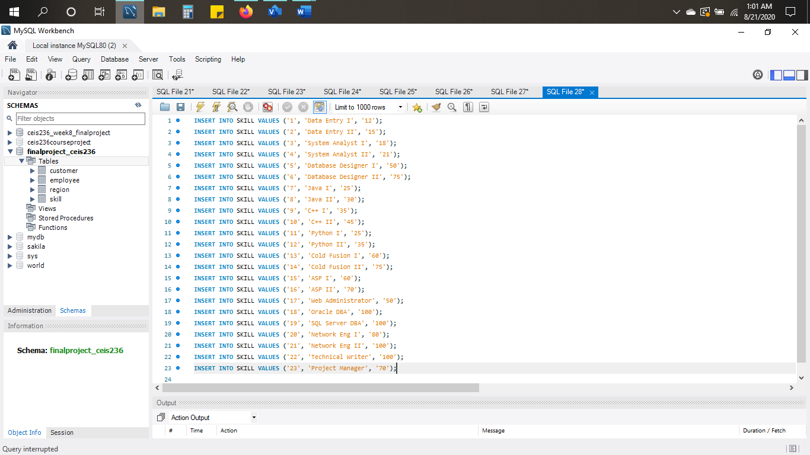

**Screenshot in MySQL of sample data in Skill table:**

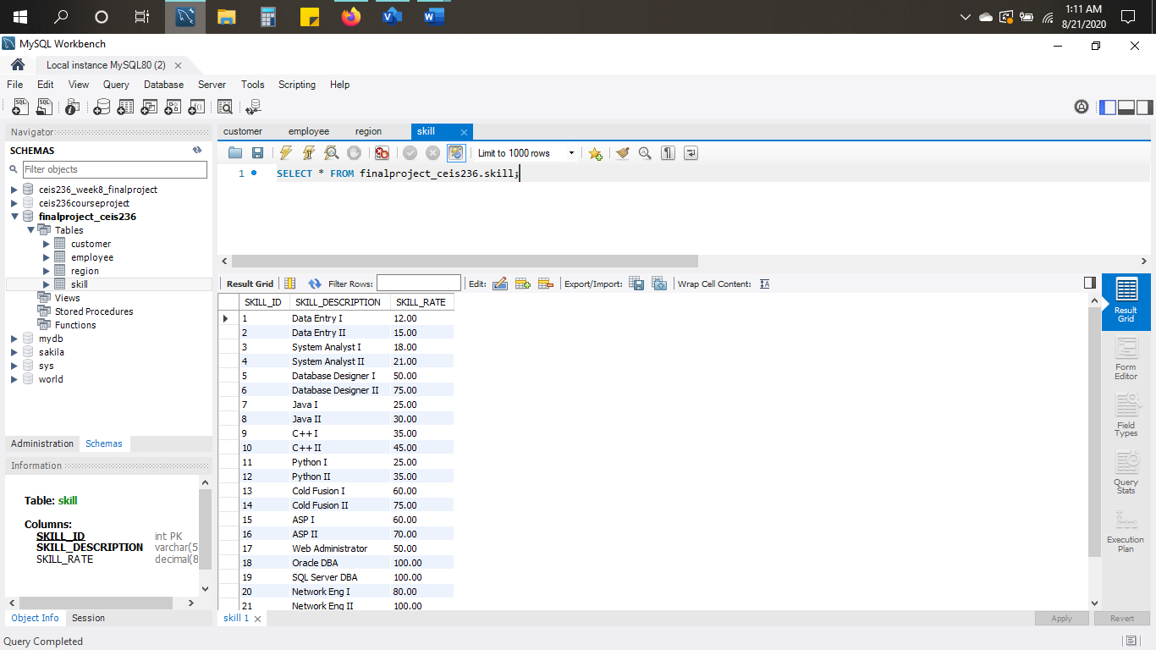

* **Write a query to practice aggregation functions.**

**Query:**

SELECT COUNT(EMP_ID)

FROM employee;

**Screenshot with result:**

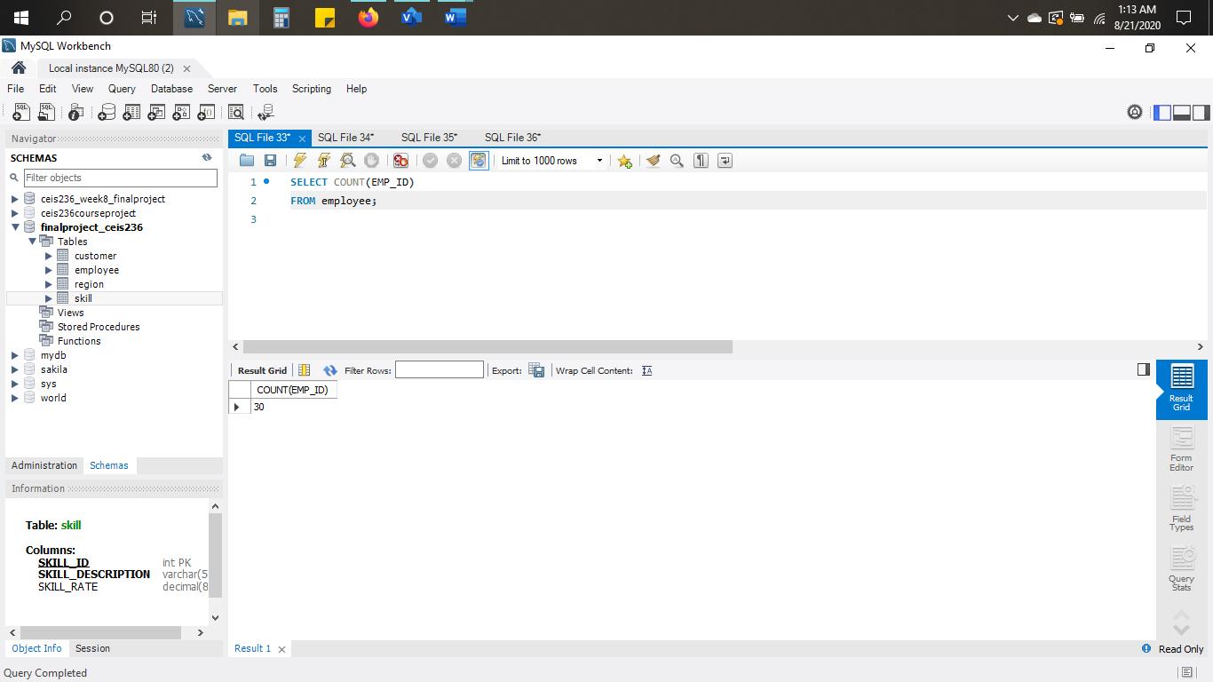

* **Write a query to practice joins.**

**Query:**

SELECT customer.CUS_ID, customer.CUS_NAME, employee.EMP_FNAME, employee.EMP_LNAME

FROM CUSTOMER

JOIN EMPLOYEE ON customer.REGION_ID = employee.REGION_ID

ORDER BY CUS_ID;

**Screenshot with result:**

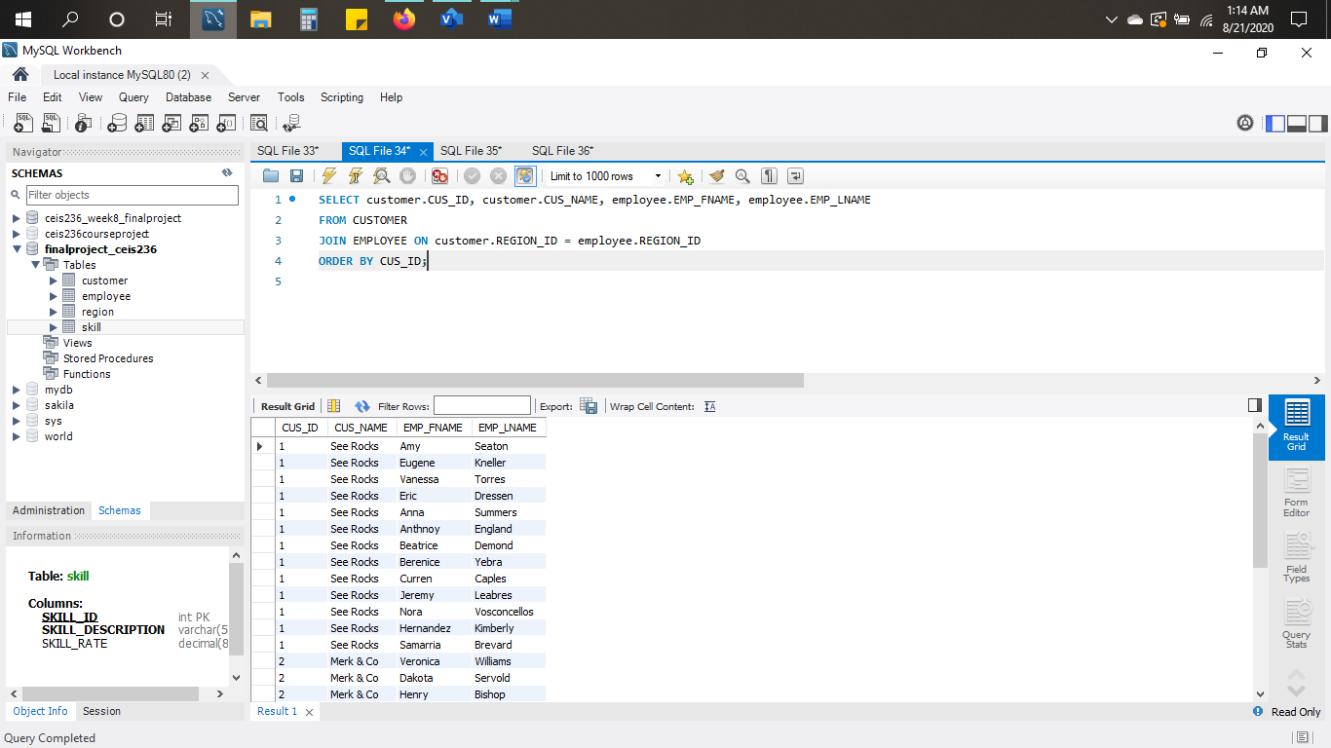

* **Write a query to practice subqueries.**

**Query:**

SELECT *

FROM EMPLOYEE

WHERE REGION_ID > (SELECT AVG(REGION_ID) FROM EMPLOYEE);

**Screenshot with result:**

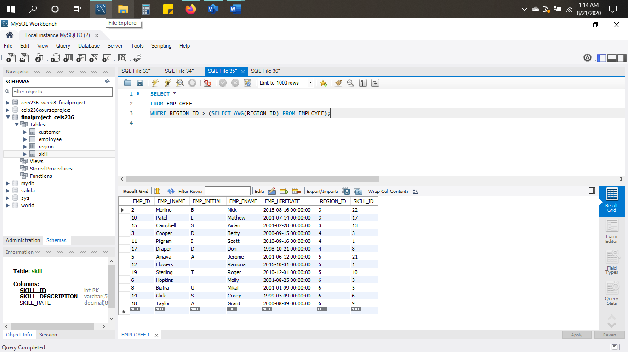

* **Write a query to practice view creation.**

**Query:**

CREATE OR REPLACE VIEW EMPLOYEE_LIMITED_VIEW AS

SELECT EMP_FNAME, EMP_LNAME, EMP_INITIAL, EMP_HIREDATE

FROM EMPLOYEE;

SELECT *

FROM EMPLOYEE_LIMITED_VIEW; /* TO VERIFY RESULTS*/

**Screenshot with result:**

