**COURSE PROJECT: The Getta Byte – New Billing System Project**

Kimberly Hernandez

DeVry University

MGMT404: Project Management

Professor Vincent Parry

January 2022

Table of Contents

Introduction2

Part 13

Section A: Project Charter3

Section B: Stakeholder Engagement Plan4

Part 26

Section C: Communication Plan5

Section D: The Project Scope Statement 6

Part 38

Section E: The Project Schedule and Gantt Chart8

Section F: Resource Allocation and Budgeting 9

Part 410

Section G: Risk Management 10

Conclusion11

References12

**Introduction**

Getta Byte Software is taking charge of replacing a manual billing system by developing a new billing system. Getta Byte Software’s expectation of the New Billing System project will be automated, fast, accurate, and work online. Other expectations of the project include saving labor costs by 25% every month, easy data entry, and dynamic updates to receivables. While the project has several requirements it must meet, the milestones to reach those requirements include development and testing to be done by August 15th, First Pilot to be done by September 1st, and the final release of the product will be on September 10th.

Getta Byte Software’s appointment project manager is Ima Payne who plans on working alongside several key stakeholders and department areas for the new billing system project. Key stakeholders include the CEO Haywood U. Buzzoff, CFO Kent C De Trees, Financial Direct Lou Seguzi, and her project team members: Hugh Duitt, Nonia Bizness, Don Testit, Kurt Anser. The key stakeholders will take part throughout the project for decisions, updates, and goals. Other departments that are part of the project include Accounts Payable, Finance, Accounting, Database, and IT departments as well as the Business Analyst.

The project management methodology will go through the waterfall methodology of initiating, planning, executing, monitoring & controlling, and closing phase. The phases of the project will be broken down into major deliverables such as the initial meeting, requirements gathering, development, and testing, completed pilot, and final product release. While Ima Payne will take this approach, enterprise environmental factors that will influence the project are the resources available, hierarchy and authority, company infrastructure, and information technology software. The project budget will limit the resources needed which also includes her staffed team. The hierarchy and authority include going through key stakeholders for major decisions and additional resources. The infrastructure and information technology software of the facility includes the versions of the hardware and software that are currently installed that could cause incompatibility with the project as well as the current network infrastructure updates that may cause errors.

PART 1

**Section A: The Project Charter**

|  |  |  |  |
| --- | --- | --- | --- |
| **PROJECT CHARTER** | | | |
| **Project Name** | New Billing System | **Project #: 1** | |
| **Project Manager** | Ima Payne | **Start Date**  01, 03, 2022 | **End Date**  09, 10, 2022 |
| **Project Sponsor** | Haywood U. Buzzoff / Lou Seguzi | | |

Project Description:

*To provide high-quality service to end-users of the current manual billing system, a new billing system will be implemented. Getta Byte’s New Billing System project will take the place of the current manual billing system to provide an automated, fast, and accurate system. At project completion, end-users will have access to the system online with the ability for easy data entry, report generating, and* *quick transactions along with response times. This also entails that the system will dynamically update receivables.*

Objectives

* *Automated, fast, and accurate system*
* *Allow easy data input*
* *Receivables are dynamically updated*
* *Save 25% in labor costs every month*
* *Work online*
* *Accept card payment methods*
* *Allow for* *customer information to be viewed, printed, or deleted.*

Business Need:

*This project was initiated to replace the current billing system that is manual, time-consuming, and inaccurate. The current billing system has all entries done manually leaving room for inaccuracy in transactions. This also leaves departments in billing, accounting, and sales with longer wait times as well as longer transaction times. The New Billing System will create a fast and efficient environment for its end-users where transactions can easily be performed with most of the labor done by the system automatically. Projected benefits after the roll-out date of the New Billing System will have successfully reduced billing cycles by 30% and save on labor costs by 25% per month.*

Milestones

| **Milestones** | **Estimated Completion Timeframe** |
| --- | --- |
| Initial Meeting | 01, 31, 2022 |
| Complete WBS | 02, 09, 2022 |
| Complete requirements gathering and analysis | 02, 14, 2022 |
| Development and testing | 08, 15, 2022 |
| The first pilot done | 09, 01, 2022 |
| Test Closure | 09, 06, 2022 |
| Final product release | 09, 10, 2022 |

Budget

|  |  |
| --- | --- |
| Estimated Work Cost | $150,000 |
| Estimated Material & Equipment Cost | $100,000 |
| Fixed Cost | $0 |
| **TOTAL ESTIMATED COST** | 250, 000 |

User Acceptance Criteria

*To measure the success of the project, the New Billing System will:*

* *Reduce billing cycles by 30%*
* *Dynamically generate reports*
* *Speed up system transactions and response times*

*Once the new billing system has reached its pilot testing phase, we can determine transaction and response times. During this phase, stakeholders can confirm that processes have been sped up when compared to the manual system. Stakeholders can also measure the success or failure of reports dynamically generated by viewing the information in the system after transactions have been processed. If all criteria are a success, then the New Billing System is expected to have reduced billing cycles by 30% after product roll-out.*

High-Level Project Assumptions

* *All customer data is correct.*
* *The accounts receivable system will remain the same.*
* *The financial system of record will remain the same.*
* *The network and server will run properly.*
* *The database will allow the system to create queries on customers and report information.*
* *All customer information will be secured on the server.*
* *No issues with software installment on all systems.*

High-Level Project Constraints

* *The budget must remain within the $250,000 range.*
* *The accounts receivable system will remain the same.*
* *The financial system of record will remain the same except for the interface.*
* *The first pilot must be completed by September 1st.*
* *The final product must be done by September 10th.*
* *Database queries support information stored in the database to generate reports.*
* *Reliable network connection for system to remain online*
* *Versions of hardware and computer software are compatible to install the new system.*

Project Exclusions

* *No upgrade to accounts receivable system.*
* *No changes to the financial system of record.*
* *Verification of current customer data.*
* *Confirming database queries for the system.*
* *Confirm database collects information that is added from system input.*
* *Installing or updating appropriate hardware and computer software to run the new billing system.*

Major Project Risks

* *Network issues during replacement*
* *Data transfer risk*
* *Current customer data contains errors and generates reports with inaccurate reports.*
* *Exceed budget capacity.*
* *Not meeting ‘Test Closure’ by September 6th caused a delay in product deployment.*
* *Installation issues on the system.*
* *Team members may lose interest in the project resulting in finding a replacement.*

Key Stakeholders

*Project manager Ima Payne will work with the following stakeholders:*

* *Customers*
* *CEO*
* *CFO*
* *Financial Director*
* *Finance*
* *Billing*
* *Customer Service*
* *Sales*
* *Accounts Payable*
* *project team members.*

**Section B**: **Stakeholder Engagement Plan**

|  |  |  |  |  |  |  |  |  |  |
| --- | --- | --- | --- | --- | --- | --- | --- | --- | --- |
| **Stakeholder Engagement Plan** | | | | | | | | | |
| Project Name: New Billing System | | | | | | Project Manager: Ima Payne | | Date: 01-07-2022 | |
| Stakeholder Identification | | | Stakeholder Analysis | | | Engagement Strategy | | | |
| **Stakeholder** | **Role** | **Category** | **Influence** High/Low | **Interest** High/Low | **Key Interests**  **& Needs** | **Strategy** | **Strategic Approach** | **Strategy Owner** | **Frequency**  **& Method**  (Based on needs) |
| Haywood U. Buzzoff | CEO | Key | High | High | Project deadline & company savings. Needs weekly updates. | inform | Engage them on regular basis for decisions (Face to face) | IPS | Weekly meetings face-to-face or online (Zoom & Asana), phone calls, and emails (corporate email). |
| Kent C. De Trees | CFO | Key | High | High | Project deadline & needs weekly updates. | Manage | Engage them on regular basis for decisions (Face to face) | PMO | Weekly meetings face-to-face or online (Zoom & Asana), phone calls, and emails (corporate email). |
| Lou Seguzi | Director Fin | Key | High | High | Project needs and weekly updates. | satisfy | Engage them on regular basis for decisions (Face to face) | IPS | Weekly meetings (Zoom & Asana) and phone calls. |
| Accounts Payable Team | Billing | Primary | High | Low | Weekly updates. | satisfy | Keep satisfied by meeting their needs. Work to increase their low-interest level | SME | Weekly emails (corporate email). |
| Finance Department | Reporting | Primary | High | Low | Weekly updates. | satisfy | Keep satisfied by meeting their needs. Work to increase their low-interest level | SME | Weekly emails (corporate email). |
| Accounting Team | Processing | Primary | High | Low | Weekly updates. | satisfy | Keep satisfied by meeting their needs. Work to increase their low-interest level | SME | Weekly emails (corporate email). |
| Sales Team | Sales | Secondary | High | Low | Weekly updates. | satisfy | Keep satisfied by meeting their needs. Work to increase their low-interest level | SME | Weekly emails (corporate email). |
| Ima Payne | Project Manager | Key | High | High | Project deadlines, needs, conflicts, progress, budget, daily updates from team members and database and IT departments. | Manage | Work to maintain a relationship with all stakeholders involved. | PM | Weekly meetings, face-to-face or online (Zoom & Asana), phone calls, emails (corporate email), and daily instant messages (Slack |
| Hugh Duitt | Team Member | Key | High | High | Project deadlines, conflicts, progress, daily updates. | manage | Manage closely by keeping them involved in project decisions.  Engage them on regular basis.  Work to maintain a relationship. | PM | Weekly meetings face-to-face or online (Zoom & Asana), and emails (corporate email). Daily instant messages (Slack). |
| Nonia Bizness | Team Member | Key | High | High | Project deadlines, conflicts, progress, daily updates. | manage | Manage closely by keeping them involved in project decisions.  Engage them on regular basis.  Work to maintain a relationship. | PM | Weekly meetings face-to-face or online (Zoom & Asana), and emails (corporate email). Daily instant messages (Slack). |
| Don Testit | Team Member | Key | High | High | Project deadlines, conflicts, progress, daily updates. | manage | Manage closely by keeping them involved in project decisions.  Engage them on regular basis.  Work to maintain a relationship. | PM | Weekly meetings face-to-face or online (Zoom & Asana), and emails (corporate email). Daily instant messages (Slack). |
| Kurt Anser | Team Member | Key | High | High | Project deadlines, conflicts, progress, daily updates. | manage | Manage closely by keeping them involved in project decisions.  Engage them on regular basis.  Work to maintain a relationship. | PM | Weekly meetings face-to-face or online (Zoom & Asana), and emails (corporate email). Daily instant messages (Slack). |
| Business Analyst | Team Member | Key | High | High | Project deadlines, needs, conflicts, progress, budget, daily updates from team members and all departments. | Manage | Manage closely by keeping them involved in project decisions.  Engage them on regular basis.  Work to maintain a relationship. | PMO | Weekly meetings face-to-face or online (Zoom & Asana), and emails (corporate email). Daily instant messages (Slack). |
| Database Department | Database Administrator | Secondary | Low | Low | Monthly updates | inform | Monitor communication for changes in influence and interest.  Keep them updated. | SME | Monthly emails (corporate email). |
| IT Department | Technician | Secondary | Low | Low | Weekly updates. | inform | Monitor communication for changes in influence and interest.  Keep them updated. | SME | Monthly emails (corporate email). |

**Strategy Owner: The strategy owner could be the project manager, program manager, internal project sponsor, the Project Management Office, or any team member suitable for the job.**

**Part 2**

**Section C: Communication Plan**

|  |  |  |  |  |  |  |  |  |
| --- | --- | --- | --- | --- | --- | --- | --- | --- |
| **COMMUNICATIONS MANAGEMENT PLAN** | | | | | | | | |
| Project Name: | | Getta Bill | | | | | | |
| Project Manager Name: | | Ima Payne | | | | | | |
| Project Description: | | To provide high-quality service to end-users of the current manual billing system, a new billing system will be implemented. Getta Byte’s New Billing System project will take the place of the current manual billing system to provide an automated, fast, and accurate system. At project completion, end-users will have access to the system online with the ability for easy data entry, report generating, and quick transactions along with response times. This also entails that the system will dynamically update receivables. | | | | | | |
| **ID** | **Communication Vehicle** | **Target Audience** | **Description/Purpose** | **Frequency** | **Sender** | **Distribution Vehicle** | **Internal / External?** | **Comments** |
| 0 | Weekly status meeting | Project Team | Project status updates | Weekly | Ima Payne | Face-to-face meeting | Internal Only | Full Team meeting we will invite stakeholders when necessary. |
| 1 | Steering Committee Review | CEO, CFO, Finance Director, Sales Director, Project Manager, Data Architect | Update current status of project & obstacles | Monthly | Ima Payne | Face-to-face meeting | Internal Only | Communicate project progress to the steering committee. |
| 2 | Weekly Status Report | CEO, CFO, Director of Finance, Director of Accounting, Project Team | Status updates, current timeline, key accomplishments, planned work | Weekly | Ima Payne | Email | Internal Only |  |
| 3 | Data Status Reports | CEO, Financial Director, Data architect, Database Department, IT department, Business Analyst, Project Team, Project Manager | Project status, Planned work for database, | Bi-Weekly | Data architect, Ima Payne | Online Meeting | Internal Only | Communicate progress and plans for data validation and cloud transfer including project progress. |
| 4 | Monthly Status Reports | CEO, CFO, Finance Director, Billing Representative, Data architect, Database Department, IT Department, Business Analyst, Project Team, Project Manager | Project status and planned work for installations | Monthly | Ima Payne, IT department | Online Meeting | Internal Only | Communicate software installation including testing environment and network status. |
| 5 | Daily Status Report | Stakeholders | Performance status, manage stakeholder’s expectations | Daily | Ima Payne, Project Team | Phone Conference | External and Internal | Communicate individual performance goals and status as well as manage stakeholders’ expectations |

**Note: The table below provides information on how to complete each of the columns of the communication management plan.**

|  |
| --- |
| **Instructions For Completing This Document** |
| Complete the Project Name, NC, Project Manager Name, and Project Description fields |
| For each identified communication, complete the following. |
| **ID:** A unique ID number is used to identify the communication within the communication matrix. |
| **Communication Vehicle:** This column should be populated with a description of the type of communication that will be conducted. |
| **Target Audience:** This field should be populated with a description of the target audience for this communication vehicle. |
| **Description/Purpose:** This field should be populated with a description of the purpose of the communication. |
| **Frequency:** This field should be populated with the frequency of which the communication will be distributed. |
| **Owner:** This field should be populated with the name of the owner of the communication. |
| **Distribution Vehicle:** This field should be populated with the type of distribution vehicle that will be used to disseminate the communication. |
| **Internal/External:** This field should indicate if the communication is for internal, external, or both internal and external distribution. |
| **Comments:** This column should be populated with any additional comments. |

**Section D: The Project Scope Statement**

|  |  |  |  |
| --- | --- | --- | --- |
| **PROJECT SCOPE STATEMENT** | | | |
| **Project Name** | Getta Bill | **Project #: 1** | |
| **Project Manager** | Ima Payne | **Start Date**  01, 03, 2022 | **End Date**  09, 10, 2022 |
| **Project Sponsor** | Haywood U. Buzzoff / Lou Seguzi | | |

Project Description

*To provide high-quality service to end-users of the current manual billing system, a new billing system will be implemented. Getta Byte’s New Billing System project will take the place of the current manual billing system to provide an automated, fast, and accurate system. At project completion, end-users will have access to the system online with the ability for easy data entry, report generating, and quick transactions along with response times. This also entails that the system will dynamically update receivables.*

Project Requirements

* *Cloud-based system to access online.*
* *Accessibility to all billing representatives.*
* *Generate specific dynamic reports for the number of customers billed.*
* *Generate specific dynamic reports on total billing for various periods.*
* *Ability to drill down for details.*
* *Audit capabilities.*
* *Reduce billing errors by 15%.*
* *Reduce billing cycles by 30%.*
* *Produce accurate data for all customers.*
* *Accept card payment methods.*
* *View, print, or delete customer information.*
* *Easy system navigation and data entry for all end-users.*
* *Perform quick transactions along with system response times.*

Project Deliverables

*For the Getta Bill project to deliver accurate data for all customers, be accessible to billing representatives, and be a cloud-based system the following deliverables must be completed:*

* *Requirements must be gathered based on users and customers.*
* *A vendor must be selected.*
* *A contract must be negotiated*
* *A software purchase must be executed.*
* *Software is customized to define features.*
* *A test environment must be set up.*
* *Development is performed on custom software.*
* *Testing is performed on custom software.*
* *Data is processed by validation, map fields, and a cloud transfer.*
* *Training is conducted after developing training with vendors and scheduling training with customer service representatives.*
* *And lastly, the system is released into production.*

Project Exclusions

* *No upgrade to accounts receivable system.*
* *No changes to the financial system of record except to interface.*
* *No changes to the current network.*
* *Verification of current customer data.*
* *Confirming database queries for the system.*
* *Confirm database collects information that is added from system input.*
* *Installing or updating appropriate hardware and computer software to run the new billing system.*

Acceptance Criteria

*To measure the success of the project, the New Billing System will:*

* *Reduce billing cycles by 30%*
* *Dynamically generate reports*
* *Speed up system transactions by 30% and response times*
* *Ease of use including system navigation and data entry*

*Once the new billing system has reached its pilot testing phase, we can determine transaction and response times. During this phase, stakeholders, including some of the billing representatives, can confirm that processes have been sped up by 30% when compared to the manual system. Stakeholders can also measure the success or failure of reports dynamically generated by viewing the information in the system after transactions have been processed. If all criteria are a success, then the New Billing System is expected to have reduced billing cycles by 30% after product roll-out.*

Estimated Project Schedule

| **Milestones** | **Estimated Completion Timeframe** |
| --- | --- |
| Initial Meeting | 01, 07, 2022 |
| Complete WBS | 01, 10, 2022 |
| Complete requirements gathering and analysis | 01, 14, 2022 |
| Purchase software | 03, 08, 2022 |
| Development | 08, 19, 2022 |
| Customize software and testing | 09, 02, 2022 |
| Transfer data to the cloud | 09, 26, 2022 |
| Train personnel | 12, 01, 2022 |
| The first pilot done | 01, 13, 2023 |
| Test Closure | 01, 20, 2023 |
| Final product release | 01, 23, 2023 |

Resource Requirements

|  |  |  |
| --- | --- | --- |
| Role | Total Individuals Involved | Estimated Duration Involved |
| *Data Architect* | *1* | *5 Months* |
| *Developers* | *2* | *5 Months* |
| *Billing representatives* | *2* | *2 Months* |
| *Project Team Member* | *4* | *8 Months* |
| *Project Manager* | *1* | *8 Months* |
| *IT Technician* | *1* | *5 Months* |
| *Testing Environment* | *1* | *5 Months* |
| *Test Machines* | *3* | *4 Months* |

Estimated Cost of Project

|  |  |  |
| --- | --- | --- |
| Expense Type | Description | Estimated Cost |
| **Work /Labor Cost** | * Developers * Data Specialist * Project manager | $50, 000  $50, 000  $50, 000 |
| **Material & Equipment Cost** | * BillRite Software Purchase | $100, 000 |
| **Fixed Cost** |  | $0 |
| **TOTAL ESTIMATED COST OF PROJECT** | | $250, 000 |

Project Constraints

* *The budget must remain within the $250,000 range.*
* *The accounts receivable system will remain the same.*
* *The financial system of record will remain the same except for the interface.*
* *Customer data migrated to the cloud completely by August 25th.*
* *The first pilot must be completed by September 1st.*
* *The final product must be done by September 10th.*
* *Database queries support information stored in the database to generate reports.*
* *Reliable network connection for system to remain online*
* *Versions of hardware and computer software are compatible to install the new system.*

Project Assumptions

* *All customer data is correct.*
* *The accounts receivable system will remain the same.*
* *The financial system of record will remain the same.*
* *The network and server will run properly.*
* *No troubleshooting with the network.*
* *The database will allow the system to create queries on customers and report information.*
* *All customer information will be secured on the server.*
* *No issues with software installment on all systems.*

**Part 3**

**Section E**: **The Project Schedule and Gantt Chart**

Project Schedule

| **WBS Index** | **Task Name** | **Duration** | **Start** | **Finish** | **Predecessors** |
| --- | --- | --- | --- | --- | --- |
| **1** | **GETTA BYTE- Billing Project** | **140** |  |  |  |
| **1.1** | **Finalize Requirements** | **10** |  |  |  |
| 1.1.1 | Gather requirements from users | 5 days | 1/3/2022 | 1/7/2022 |  |
| 1.1.2 | Gather requirements from customers | 5 days | 1/10/2022 | 1/14/2022 | 1.1.1 |
| **1.2** | **Purchase Software** | **35** |  |  |  |
| 1.2.1 | Select Vendor | 20 days | 1/17/2022 | 02/11/2022 | 1.1.1 |
| 1.2.2 | Negotiate Contract | 10 days | 02/14/2022 | 02/25/2022 | 1.2.1 |
| 1.2.3 | Execute purchase | 5 days | 02/28/2022 | 03/04/2022 | 1.2.2 |
| 1.3 | **Customize Software** | **45** |  |  |  |
| 1.3.1 | Define features | 10 days | 03/07/2022 | 03/18/2022 | 1.2.3 |
| 1.3.2 | Set up test environment | 5 days | 03/21/2022 | 03/25/2022 | 1.3.1 |
| 1.3.3 | Develop customization | 20 days | 03/28/2022 | 04/22/2022 | 1.3.2 |
| 1.3.4 | Test customization | 10 days | 04/25/2022 | 05/06/2022 | 1.3.3 |
| 1.4 | **Transfer Data to Cloud** | **15** |  |  |  |
| 1.4.1 | Validate data | 5 days | 05/09/2022 | 05/13/2022 | 1.3.4 |
| 1.4.2 | Map fields | 5 days | 05/16/2022 | 05/20/2022 | 1.4.1 |
| 1.4.3 | Transfer data | 5 days | 05/23/2022 | 05/27/2022 | 1.4.2 |
| 1.5 | **Train Personnel** | **30** |  |  |  |
| 1.5.1 | Develop training with vendor | 10 days | 05/30/2022 | 06/10/2022 | 1.4.3 |
| 1.5.2 | Schedule training for CSRs | 10 days | 06/13/2022 | 06/24/2022 | 1.5.1 |
| 1.5.3 | Conduct training | 10 days | 06/27/2022 | 07/08/2022 | 1.5.2 |
| 1.6 | **Go Live** | **5** |  |  |  |
| 1.6.1 | Release system to production | 5 days | 07/11/2022 | 07/15/2022 | 1.5.3 |

Gantt Chart

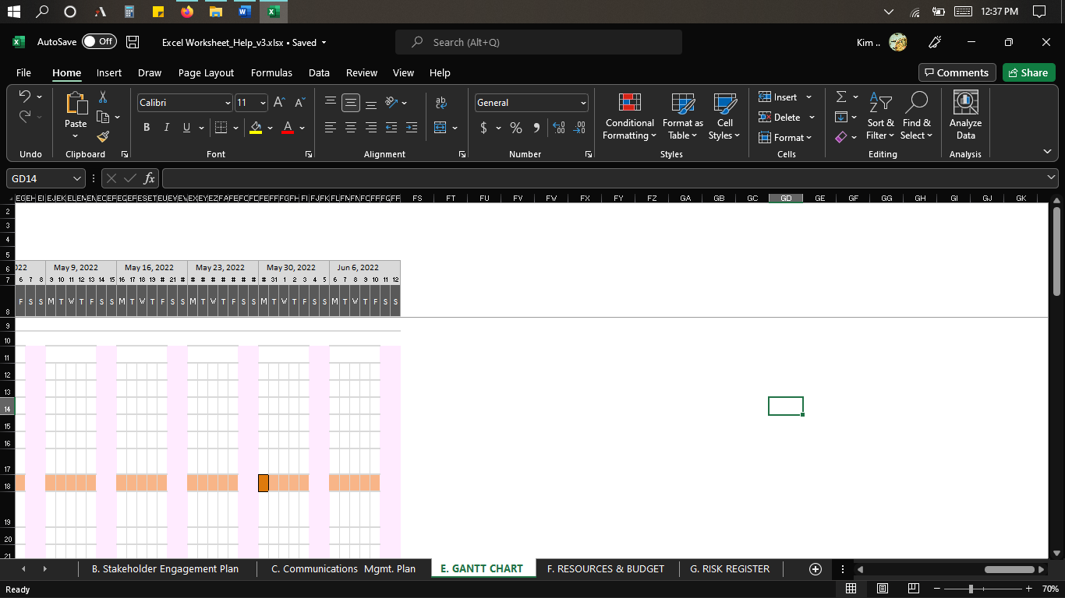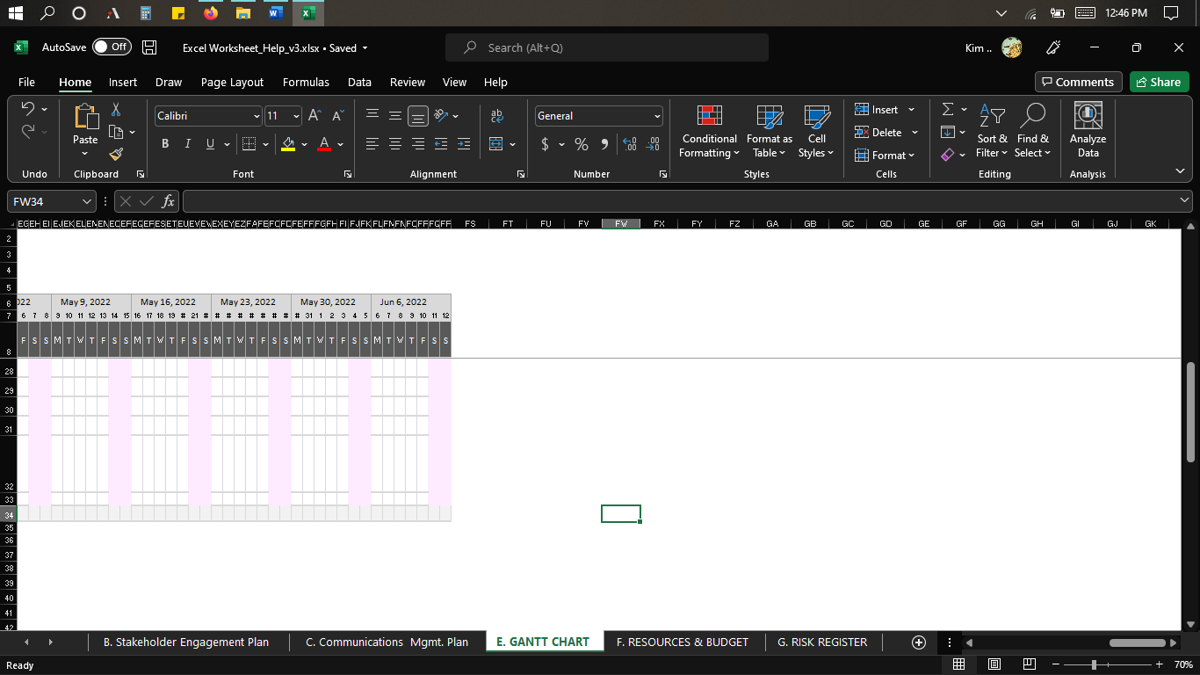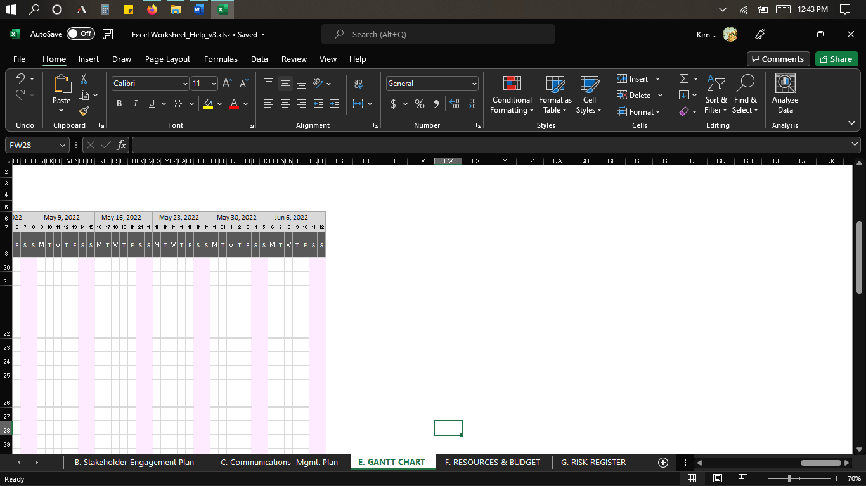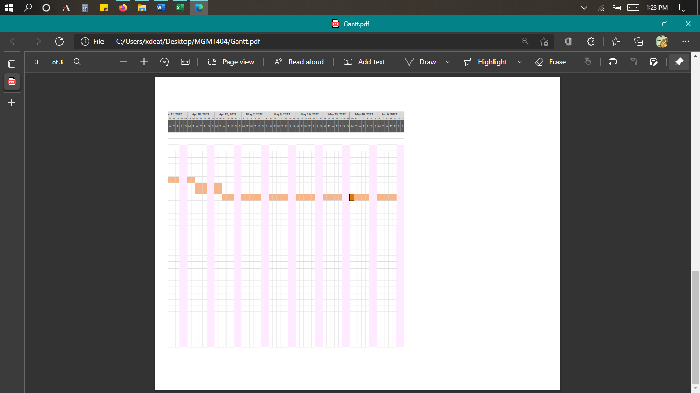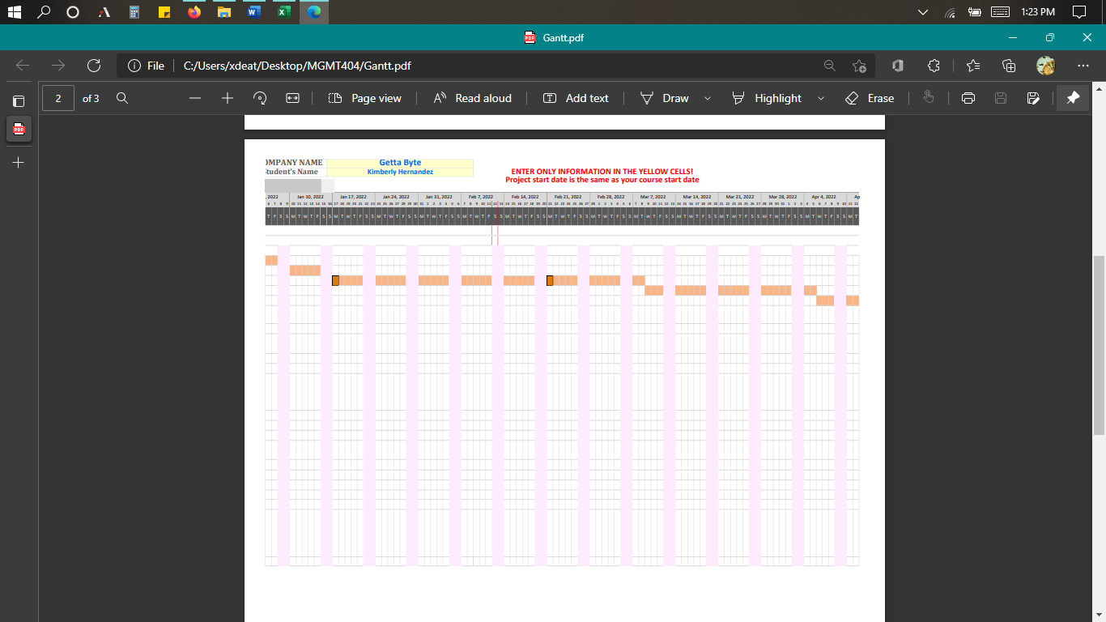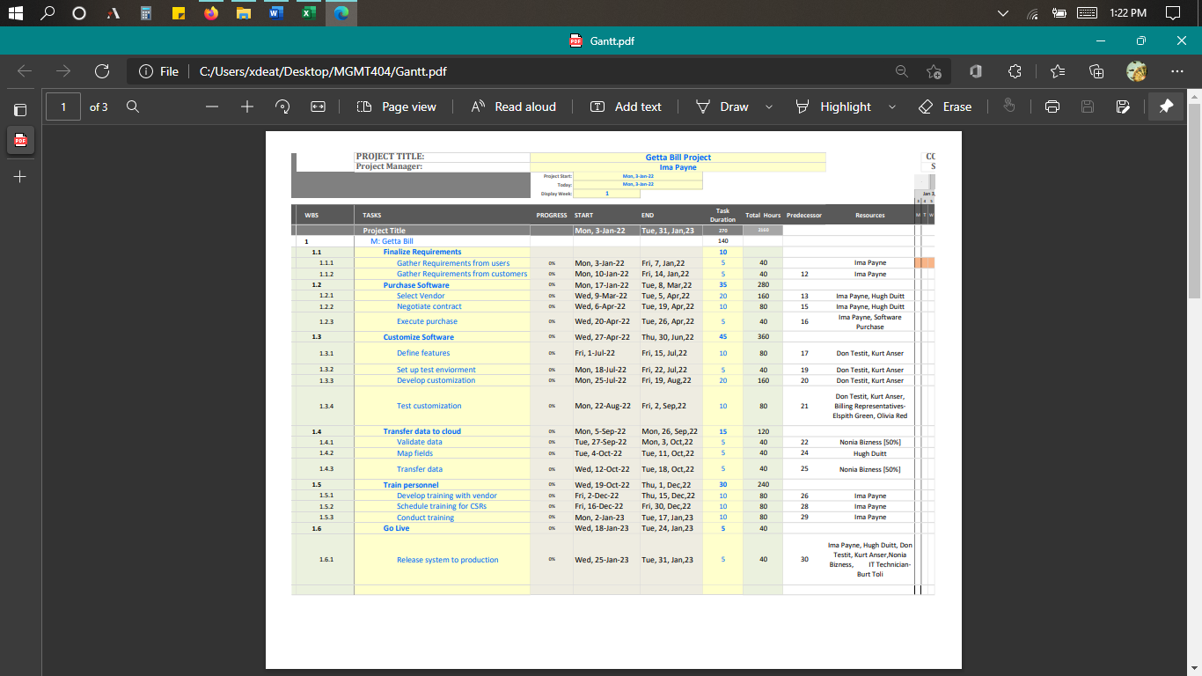

Section F: Resource allocation and budgeting

Section G: Risk Management

|  |  |  |  |  |  |  |  |  |  |  |  |  |  |  |  |  |  |  |
| --- | --- | --- | --- | --- | --- | --- | --- | --- | --- | --- | --- | --- | --- | --- | --- | --- | --- | --- |
|  | **IDENTIFY  RISK** | | | | | | | | **PERFORM QUALITATIVE  RISK ASSESSMENT** | | | | | **PLAN RISK RESPONSE** | | | **IMPLEMENT RISK PLAN** | **MONITOR  RISK** |
|  | **ID** | **WBS** | **Task Name** | | **RBS Category** | **Risk Identified** (Description) | **Root Cause  of the Risk** | **Risk Impact** + / - | **Prob.** | **Impact  on Cost** | **Impact  on Sch.** | **Impact  on Quality** | **Risk Score** | **Risk Owner** | **Risk Strategy** + / - | **Risk Response Plan** | **Risk Action Owner** | **Risk  Status** |
| Negative | **NEGATIVE RISK** | | | | | | | | | | | | | | | | | |
|  | 1 | 1.4.3 | Transfer Data | | Organizational | **Network Capacity**  (Failure during uploads) | Low bandwidth | Negative Impact on Schedule | 3 | 2 | 3 | 5 | **3** | Network Services | **- Mitigate** | * Review bandwidth requirements * Research best vendors for needs * Select vendor for high bandwidth * Conduct network assessment and troubleshoot prior to migration | Don Testit (Developer) | **Active** |
|  | 2 | 1.4.2 | Map fields | | Technical | **Data errors** (Error during the process of matching fields) | Field mapping errors | Negative Impact on Schedule | 1 | 1 | 2 | 1 | **0.4** | Data Architect | **- Accept** | *Test mapping on data sample | Hugh Duitt (Data architech) | **Active** |
|  | 3 | 1.4.1 | Validate Data | | Technical | **Customer data integrity** (Data mismatches or data errors) | * Script errors * Database mismatch | Negative Impact on Schedule | 5 | 2 | 4 | 1 | **4** | Data Specialist | **- Mitigate** | * Validate data on data sample | Nonia Buziness (Data Specialist) | **Active** |
|  | 4 | 1.1.1 | Gather Requirement from users | | External | **Scope definition**  (Users interviewed for gathering of requirements did not the experience nor background to provide information.) | Users interviewed did not have experience in the billing department | Negative Impact on Schedule, Budget, Quality | 4 | 3 | 4 | 4 | **3.2** | Project Manager | **- Mitigate** | * Be selective when interviewing users. * Users must have worked in the billing dpt. two years or more and must be familiar with billing processes  * User must have operational & technical background. | Ima Payne Project Manager) | **Expired** |
|  | 5 | 1.3.2 | Set up test environment | | Technical | **Installation failure** (Software installation was not fully successful) | Weather conditions cause power and network outage. | Negative Impact on Schedule and Budget | 2 | 5 | 5 | 1 | **2** | Project Manage, IT Technician | **- Mitigate** | * Test uninterruptible power supplies. *Ensure facility backup generators are in working condition. | Bert Toli (IT Technician) | **Active** |
|  | 6 | 1.3.4 | Test customization | | Project Management | **Delayed testing** (Billing representatives are not experienced to test software) | The task is delayed since billing representatives did not have the required experience in testing software. | Negative Impact on Schedule, Budget, Quality | 4 | 5 | 5 | 5 | **4** | Project Manager | **- Mitigate** | * Select billing representatives that have been in the industry for 2 years.  *Ensure billing representatives know the manual system well enough to understand the customized system. *Billing representative required to know basic testing and technical inputs for software use. | Ima Payne (Project Manager) | **Active** |
|  | 7 | 1.3.3 | Develop customization | | Technical | **Poor code quality** (Errors found when customizing software) | *Code quality presented errors when developing customization *Algorithm errors | Negative Impact on Schedule | 3 | 2 | 3 | 4 | **2.4** | Developer 2 | **- Mitigate** | *Communication is clear when identifying code and algorithms used during customization tasks.  *All developers selected have strong programming skills to review code. *Verify requirements have not changed. *Review code modules and functions for code quality. | Kurt Anser (Developer) | **Active** |
|  | 8 | 1.5.3 | Conduct training | | Organizational | **Inadequate training** (Training lacked resources that lead to difficulty in understanding the new system) | *Lack of resources during training *Staff unable to grasp the functionality of online software. | Negative Impact on Schedule | 2 | 1 | 4 | 1 | **1.6** | Project Manager | **- Avoid** | *All materials should pertain to training. *Allow trainees to get hands-on experience with the system. *Ensure trainees pass test modules. | (Ima Payne) Project Manager | **Active** |
|  | **POSITIVE RISKS** | | | | | | | | | | | | | | | | | |
|  | 1 | 1.2.3 | Execute Purchase | | External | **Planning:** Significant savings on software purchase if bought on Black Friday | Holiday coming up | Positive Impact on Budget | 5 | 5 | 1 | 1 | **5** | Project Manager | **+ Exploit** | * Enter new activities in WBS to ensure actions are taken * Meet with mgmt. and vendor * Delay purchase to Black Friday | Ima Payne (Project. Manager) | **Active** |
|  | 2 | 1.5.1 | Develop Training with Vendor | | External | **Market:** Off the shelf training modules could be available | Training modules available in the market | Positive Impact on Schedule | 4 | 1 | 3 | 1 | **2.4** | Project Manager | **+ Enhance** | * Gather software requirements  * Understand features and functionality.  * Research the market for off the shelf modules * Meet with vendor and team to determine suitability | Ima Payne (Proj. Manager) | **Active** |
|  | 3 | 1.2.1 | Select Vendor | | External | **Planning:** Vendor has software with pre-defined features that require less customization during the ‘customize software' activity; consider software with more features that meet stakeholder requirements. | The vendor presents software options with features that pertain to stakeholder requirements. | Positive Impact on Schedule, Budget, Quality | 5 | 5 | 5 | 5 | **5** | Project Manager | **+ Exploit** | *Verify pre-defined features in the software to meet some project requirements. *Verify software at least contains payment processing features. *Verify that the correct software package is selected before proceeding to the 'negotiated contract' task. | Ima Payne (Project Manager) | **Active** |
|  | 4 | 1.2.1 | Select Vendor | | External | **Planning:** Vendor presents discount on test machines. | Vendor has test machines for discounted prices with the purchase of software. | Positive Impact on Budget | 4 | 5 | 3 | 2 | **4** | Project Manager | **+ Exploit** | *New activities needed in WBS to purchase test machines. *Ensure test machines are suitable for hardware, software, and network configurations. *Bug testing feature available in the testing machines. | Ima Payne (Project Manager) | **Active** |
|  |  | | |

**Conclusion**

The Getta Byte Software project, which was temporary and unique, was taken through project management processes based on the traditional methodology--initiating, planning, executing, monitoring & controlling, and closing phases. The five attributes are known as cost, scope, time, and quality of this project were at the forefront of planning as these elements may outweigh one another and could affect project success.

The initiation phase started when a manual billing system needed an upgrade to software that needed to be online, fast, reliable, and accurate along with a few other requirements. Then, the planning phase began with the project charter that was created to clearly define the purpose and requirements of the billing system project. This is where the description, project objectives, business need, milestones, budget, user acceptance criteria, constraints, high-level assumptions, high-level constraints, exclusions, project risks, and key stakeholders were defined.

Next, the Stakeholder engagement and communication plan were created to consider the level of engagement that the internal and external stakeholders have throughout the project along with communication techniques to keep them engaged. These documents are important as the stakeholders involved can influence the project overall and strategically planning these areas can help in project success. Next, the project scope statement was prepared by giving detailed information on the work involved throughout the Getta Byte Billing System project. This documentation although like the project charter defines it a bit further giving us enough information to create the project schedule, Gantt chart, and budget information. Based on a work breakdown structure (WBS), the project milestones were broken down into activities, resources, duration, completion dates that are in sequence based on its predecessors. While resources are assigned by name in the Gantt chart, the cost of the labor resources is considered for the allocation and budgeting part of the project. The budget limit of $250,000 was considered as well as other resources that are needed for project tasks to be completed; after this, the budget was at $140,960. Lastly, potential risks, including positive and negative, were identified using a risk management tool in Excel. Identifying risks are important since they can happen at any time. Planning for them and creating an approach if they occur is crucial for project success.

After planning, the project would go through executing, monitoring & controlling, and closing phases. The executing phase would take what was planned and tasks would be performed. Monitoring & controlling would be done by the project manager to ensure all tasks are on time and within budget, and if any tasks are off course the changes should be taken to get them back on track. And finally, the closing phase consists of making sure the project met all its deliverables to ensure stakeholder satisfaction as well as lessons learned from the project.

As a student new to project management concepts, the knowledge gained from this course was easy to apply and create a successful project. The knowledge of the traditional methodology used in this project can also be applied to other methodologies in future projects since they contain processes and techniques that are similar. The traditional methodology was suitable for this type of project since there was not much information provided in the beginning and it was a small project and learning that extensive planning helped define whether this project would be a success or not.

References

Anantatmula, V., Kloppenborg, T.J., & Wells, K. (2019). *Contemporary project management*. (4th ed.). Cengage Learning.

Parry, V. (n.d.). *Week 1: Introduction and lesson****.***[Class lesson]. [https://devryu.instructure.com/  
courses/76075/pages/week-1-introduction-and-lesson?module_item_id=9598190](https://devryu.instructure.com/courses/76075/pages/week-1-introduction-and-lesson?module_item_id=9598190)

Parry, V. (n.d.). *Week 2: Introduction and lesson****.***[Class lesson]. [https://devryu.instructure.com/  
courses/76075/pages/week-2-introduction-and-lesson?module_item_id=9598532](https://devryu.instructure.com/courses/76075/pages/week-2-introduction-and-lesson?module_item_id=9598532)

Parry, V. (n.d.). *Week 3: Introduction and lesson****.***[Class lesson]. [https://devryu.instructure.com/  
courses/76075/pages/week-3-introduction-and-lesson?module_item_id=9598798](https://devryu.instructure.com/courses/76075/pages/week-3-introduction-and-lesson?module_item_id=9598798)

Parry, V. (n.d.). *Week 4: Introduction and lesson****.***[Class lesson]. [https://devryu.instructure.com/  
courses/76075/pages/week-4-introduction-and-lesson?module_item_id=9598969](https://devryu.instructure.com/courses/76075/pages/week-4-introduction-and-lesson?module_item_id=9598969)

Parry, V. (n.d.). *Week 5: Introduction and lesson****.***[Class lesson]. [https://devryu.instructure.com/  
courses/76075/pages/week-5-introduction-and-lesson?module_item_id=9599060](https://devryu.instructure.com/courses/76075/pages/week-5-introduction-and-lesson?module_item_id=9599060)

Parry, V. (n.d.). *Week 6: Introduction and lesson****.***[Class lesson]. [https://devryu.instructure.com/  
courses/76075/pages/week-6-introduction-and-lesson?module_item_id=9599277](https://devryu.instructure.com/courses/76075/pages/week-6-introduction-and-lesson?module_item_id=9599277)

Parry, V. (n.d.). *Week 7: Introduction and lesson****.***[Class lesson]. [https://devryu.instructure.com/  
courses/76075/pages/week-7-introduction-and-lesson?module_item_id=9599399](https://devryu.instructure.com/courses/76075/pages/week-7-introduction-and-lesson?module_item_id=9599399)

Parry, V. [Vincent A Parry]. (January 6th, 2022). *Project Management - 10782 event (162547)* [Video]. Webex. [https://devry.webex.com/recordingservice/sites/devry/recording/  
de60e8f575a4103a89be0050568114a0/playback](https://devry.webex.com/recordingservice/sites/devry/recording/dba562205184103ab9f7005056815ee6/playback)

Parry, V. [Vincent A Parry]. (January 10th, 2022). *Project Management - 10782 event (164222)* [Video]. Webex. [https://devry.webex.com/recordingservice/sites/devry/recording/  
e5f9790a54a3103aadbc005056814297/playback](https://devry.webex.com/recordingservice/sites/devry/recording/e5f9790a54a3103aadbc005056814297/playback)

Parry, V. [Vincent A Parry]. (January 20th, 2022). *Project Management - 10782 event (164223)* [Video]. Webex. [https://devry.webex.com/recordingservice/sites/devry/recording/  
ab6ee9395c7f103ab6f50050568124a3/playback](https://devry.webex.com/recordingservice/sites/devry/recording/ab6ee9395c7f103ab6f50050568124a3/playback)

Parry, V. [Vincent A Parry]. (January 24th, 2022). *Project Management - 10782 event (164224)* [Video]. Webex. [https://devry.webex.com/recordingservice/sites/devry/recording/  
6be27c5b5fa4103ab6870050568116ea/playback](https://devry.webex.com/recordingservice/sites/devry/recording/6be27c5b5fa4103ab6870050568116ea/playback)

Parry, V. [Vincent A Parry]. (January 31st, 2022). *Project Management - 10782 event (164225)* [Video]. Webex. [https://devry.webex.com/recordingservice/sites/devry/recording/  
59600d6a6524103ab6e70050568f95d3/playback](https://devry.webex.com/recordingservice/sites/devry/recording/59600d6a6524103ab6e70050568f95d3/playback)

Parry, V. [Vincent A Parry]. (February 7th, 2022). *Project Management - 10782 event (164226)* [Video]. Webex. [https://devry.webex.com/recordingservice/sites/devry/recording/  
fc1a4b1c6aa6103abedf0050568124a3/playback](https://devry.webex.com/recordingservice/sites/devry/recording/fc1a4b1c6aa6103abedf0050568124a3/playback)

Parry, V. [Vincent A Parry]. (February 14th, 2022). *Project Management - 10782 event (164227)* [Video]. Webex. [https://devry.webex.com/recordingservice/sites/devry/recording/  
db086d087026103aaf6f005056814297/playback](https://devry.webex.com/recordingservice/sites/devry/recording/db086d087026103aaf6f005056814297/playback)

Parry, V. [Vincent A Parry]. (February 21st, 2022). *Project Management - 10782 event (164228)* [Video]. Webex. [https://devry.webex.com/recordingservice/sites/devry/recording/  
de60e8f575a4103a89be0050568114a0/playback](https://devry.webex.com/recordingservice/sites/devry/recording/de60e8f575a4103a89be0050568114a0/playback)

Project Management Institute. (2017). *A Guide to the Project Management Body of Knowledge (PMBOK® Guide)* (6th ed.). <https://share.percipio.com/cd/pPgMqdVvl>